BIOL5801 Research Ethics (Spring 2021)

Instructor: Elizabeth A. Machunis-Masuoka, PhD, MA
Email: elizabeth.masuoka@msutexas.edu (best contact for questions & appointments)
Phone: 940-371-4071
Office Hours: Bolin 307D; By appointment
Class sessions: Mondays 6:00 – 6:50pm, Bolin 209

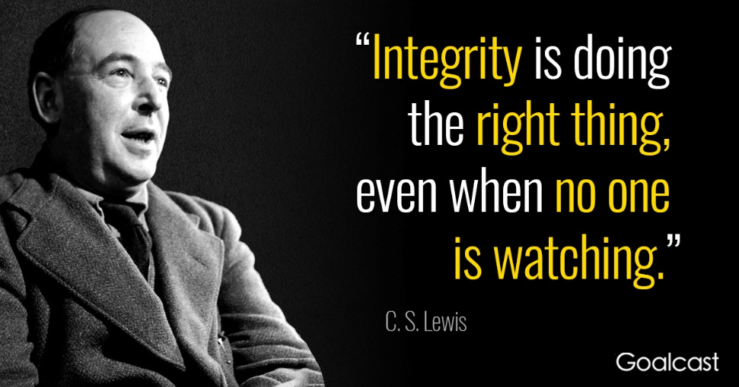

Course Description
Research ethics is concerned with the problem of scientific misconduct and includes such things as fabrication, falsification, plagiarism, conflicts of interest, authorship, and so forth. Research ethics is distinct from bioethics; for example, we might talk about fabricating data as it relates to stem cell research in research ethics, but we will not talk about whether it is morally permissible to work with the stem cells themselves. This class will be discussion based and writing intensive. All opinions are welcome and may be expressed. However, all students must recognize that everyone is entitled to their own opinion and students must accept that you are not allowed to abuse others verbally for their opinions. Debates are welcome, verbal fighting is not.

Textbook & Instructional Materials
Reference Textbook: Adil E. Shamoo and David B. Resnik (2015) Responsible Conduct of Research, 3rd edition. Oxford University Press. Reference only; not required for the class.
Papers for weekly discussions appear in the lecture schedule will be uploaded to D2L.

Useful Websites
The Office of Research Integrity (ORI)
Retraction Watch
Resources for Research Ethics Education (UCSD)
Federal Register

Attendance
This is a graduate level course that meets once per week – you are expected to attend all meetings of this class and you will be penalized for missing class. Please do NOT schedule anything for immediately after the class; discussions will likely run 30 minutes over class (thus, class will generally run 6:00pm to 7:30pm).

Late Assignments
This is a graduate level course – no late assignments will be accepted for any reason. This is especially true for the final papers and assignments that may be due at the end of the semester.

Grading
I am not an easy grader, so please do not be complacent about this course. Grades will be assessed based off of the points you earn for the following as calculated by straight percentages (i.e., I will total your points at the end and divide by the points possible and that is your grade).

Total possible points for the class: 1300 points. As the majority of the points is based on your writing, your writing must be sophisticated and as free from error as possible. Mistakes do occur and these will not be a problem if they are rare, but papers where the grammar or logic is so poor that I cannot figure out what you are trying to say will be scored very poorly. To get an A, you have to earn an A.

Assignments | Points
Free Writing (Case Study #0) | 25
Weekly Case Studies (10 at 100 points each) | 1000
Class Presentation of Misconduct Case | 100
Written Analysis of Misconduct Case | 100
Class Participation | 50
Final Exam | 25
Total Points | 1300

Phones
All phones are to be turned off in class. If playing with your phone is more important than paying attention to the discussion around you, then you do not need to be in this class.

Academic Dishonesty
Cheating, plagiarism, and collusion (as well as several other forms of conduct) are all strictly prohibited at MSU. Please read the MSU Student Handbook definitions of cheating, plagiarism, and collusion and MAKE SURE that you do not engage in any of these behaviors. If you are unclear on what may count as cheating, plagiarism, or collusion, please see me.

Plagiarism
Plagiarism will not be tolerated in this class, especially as this is a class on research ethics. There are many websites dedicated to helping you avoid plagiarism if you still need help at this point in your biology careers. Information of what plagiarism is (with examples) can be found on the Texas A&M Library website and many other institutional websites. Additionally, there are many online plagiarism (and grammar) checkers you can use for free. There is no such thing as ‘accidental’ plagiarism; thus, any papers found to contain plagiarized elements, even if minor, will receive a zero.

Assessments
You will be assessed using three basic categories:
- Writing: Each week you will be given a case study to analyze and write about. You will also write a major term paper analyzing an actual case of scientific misconduct. I will assign the case studies, but you will be allowed to pick your own misconduct case to research and write about.
- Class Presentation: You will present the misconduct case you research to the class and lead a discussion of it.
- Class Participation: Each week will consist of a brief lecture followed by class discussion of the material, various readings, and/or case studies. You are expected to actually speak in class – offering your opinion, analysis, thoughts, etc.

Writing in General
Most scientists are poor writers because they simply don’t write enough. One of my major goals (in addition to helping you be ethical scientists) is to help you learn to express yourself well in writing. Thus, you will be writing every week for this course. I will NOT, however, help you with the mechanics of writing (grammar, punctuation, etc.). I have been a science editor for almost 20 years, but you should have already learned mechanics and thus I will not pre-edit your papers. I will at least partially edit your papers in the beginning with the idea that you will, on your own, begin to thoroughly edit your own papers prior to submission. No paper is good enough to turn in on the first version. No paper written at the last minute should ever grace my desk. Every paper you write, for every class, journal, etc., should be edited at least three times and will often be re-written more than once in the course of preparation. You should get in the habit of editing and rewriting now so that you carry good habits with you when you leave MSU. If you need help with the mechanics of writing, the Writing Center over in the English Department can help you. If you need help with ideas, then stop by my office.

Weekly Case Studies – General Instructions
The weekly case studies are meant to be short papers that analyze simple case studies. All weekly case studies must be 3 pages or less, 12 point font, 1 inch margins, 1.5 spacing – do NOT deviate from these specifications. The major portion of the case study should be your solution to the problem – YOU thinking your way through the problem. You need to identify the major conflict, state how you would resolve the conflict, and then offer some sort of support for your resolution (i.e., is there a specific regulation to be followed, or a moral imperative, etc.). I am not looking for a lot of outside resources, but anything that does not come out of your own mind must be cited.

Misconduct Case – Written Assessment and Class Presentation
The ORI website has a repository of misconduct cases and their resolutions (Retraction Watch may also be consulted for cases). You are to choose one of these cases to present to the class (everyone must choose a different case, so I will require you to tell me your choice on February 15th so that I can keep track of who is doing what). You may NOT recycle old presentations used by previous students in the class.

Written Assessment: The written assessment will consist of a summary of the case (who was involved, what was the source of misconduct, what did the investigation find, what was the punitive action taken) and an analysis of the case (was this an egregious case of misconduct, how common is this type of misconduct, does the punishment fit the crime, was a crime committed, etc. – you need to do the analysis, which means you have to dissect the case and its resolution). You should read any relevant documents you can find about the case including retracted papers, if any, and weave these documents into your assessment. You should have a minimum of 10 references included in your assessment. You likely will have more.

Class Presentation: You either need a written handout or a PowerPoint presentation of the case summary so that we all know what case you covered. You then need to lead the class in a discussion (i.e., you and the class together will analyze your case; you can share your analysis and see if the class agrees or disagrees, you can ask for their assessment, etc. – this is up to you; what do you want to talk about with regard to your case). Two students will present per class, meaning that your summary and discussion can last no longer than 25 minutes.

Schedule
Date | Topic/Assigned Reading/Assignment
Jan 11 | Course Introduction  Syllabus, General ideas, Free-writing Case Study #0.5
Jan 18 | MLK Holiday—No class
Jan 25 | Scientific Research and Ethics (Ethical Principles)  - Resnik, DB (2015) “What is Ethics in Research and Why Is It Important?” Opinion Editorial. NIH.
Feb 1 | Misconduct in Research  - US Department of Health and Human Services (2005) “Public Health Service Policies on Research Misconduct.” Federal Register 70(94): 28370 – 28400.  - Homer J, Minifie FD. (2011) “Research Ethics III: Publication Practices and Authorship, Conflicts of Interest, and Research Misconduct.” Journal of Speech, Language, and hearing Research. 54: S346-S362.
Feb 8 | Data Ownership  - Deverka PA, Majumder MA, Villanueva AG, et al. (2017) “Creating a Data Resource: What will it take to build a medical information commons?” Genome Medicine. 9:84.
Feb 15 | Mentoring  - Coughlin SS, Barker A, and Dawson A. (2012) “Ethics and Scientific Integrity in Public Health, Epidemiological and Clinical Research.” Public Health Reviews. 34(1): epub ahead of print.
Feb 22 | Fraud  - Fong EA, Wilhite AW, Hickman C, and Lee Y. (2020) “The Legal Consequences of Research Misconduct: False Investigators and Grand Proposals.” The Journal of Law, Medicine & Ethics. 48: 331-339.
Mar 1 | Fabrication  - Office of the Secretary, Department of Health and Human Services. (2020) “Findings of Research Misconduct (Logan Fulford).” Federal Register 85(101): 31521-31522.  - Fulford L, Milewski D, Ustiyan V, et al. (2016; retracted 2018) “The transcription factor FOXF1 promotes prostate cancer by stimulating the mitogen-activated protein kinase ERK5.” Science Signaling. 9(427): ra48.
Mar 8 | Lab Safety  - Menard AD, Trant JF (2020) “A review and critique of academic lab safety research.” Nature: Chemistry. 12:17-25.  - Van Noorden R (2011) “A death in the lab.” Nature. 472: 270-271.  - Superior Court of the State of California for the County of Los Angeles. (2011) The People of the State of California v. The Regents of the University of California and Patrick Harran. Felony Complaint for Arrest Warrant.

Date | Topic/Assigned Reading/Assignment
Mar 15 | Patent Law  - Supreme Court of California. (1990) John Moore v. The Regents of the University of California. 51 Cal. 3d 120; 793 P.2d 479; 271 Cal. Rptr. 146; Docket No. S006987.  - Supreme Court of the United States. (1980) Diamond, Commissioner of Patents and Trademarks v. Chakrabarty. 447 U.S. 303; No. 79-136.
Mar 22 | Predatory Publishing  - United States District Court, D. Nevada. (2017) Federal Trade Commission v. OMICS Group, Inc. 302 F.Supp.3d 1184; Case No.: 2:16-cv-02022-GMN-VCF.  - United States District Court, D. Nevada. (2018) Federal Trade Commission v. OMICS Group, Inc. Case No. 2:16-cv-02022-GMN-VCF.  - United States District Court, D. Nevada. (2019) Federal Trade Commission v. OMICS Group, Incl. 374 F.Supp.3d 994. Case No.: 2:16-cv-02022-GMN-VCF.  - United States Court of Appeals, Ninth Circuit. (2020) Federal Trade Commission v. OMICS, Group, Inc. No. 19-15738.
Mar 29 | Retractions  - Retraction Watch. (2020) “Journal flags — but does not retract — decades-old paper on “correcting” gender identity”  - Brainard J, You J, Bonazzi D. (2018) “Rethinking Retractions.” Science 362(6413): 391-395.  - United States District Court for the District of Columbia. (2012) Dr. Philippe Bois v. US Department of Health and Human Services. Civil Action No. 11-1563 (ABJ)
Apr 5 | Social Responsibility  - Galson AW. (1972) “Science and Social Responsibility: A Case History.” Annals of the New York Academy of Science.  - Dyson FJ (1993) “Science in Trouble.” The American Scholar. 62(4): 513-525.
Apr 12 | Student Presentations  1.  2.
Apr 19 | Student Presentations  3.  4.
Apr 26 | FINALs Week  All outstanding papers are DUE  Student Presentations if Necessary  7.  8.

Changes in the course syllabus, procedure, assignments, and/or schedule for this course may be made at the discretion of the instructor.

