BIOL5012.270 Writing in the Biological Sciences (Spring 2021)

Instructor: Elizabeth A. Machunis-Masuoka, PhD, MA
Email: elizabeth.masuoka@msutexas.edu (best contact for questions & appointments)
Phone: 940-371-4071
Office Hours: By appointment
Class sessions: Wednesdays 6:00 – 7:50pm, Bolin 209

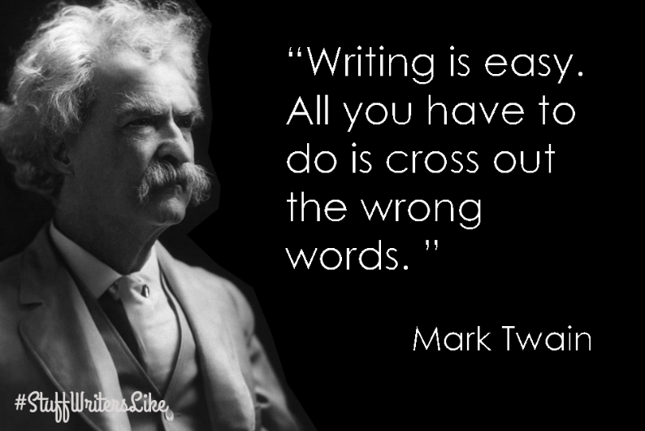

Course Overview
This course is intended to help students develop the skills required for professional scientific writing and publication and to help students become better writers overall. Effective communication is essential in the current climate of disinformation regarding science and its practice. Students will be tasked with a variety of writing projects to help them learn to properly prepare research proposals, journal articles, grants, and writing meant for non-science audiences.

Required Materials
- Text: Booth, Colomb, Williams, Bizup, and Fitzgerald. The Craft of Research. 4th edition. (University of Chicago Press). Buy from Amazon (it is cheaper) or another bookseller. This book is not in the bookstore.
- Access to D2L and other web resources as instructed.
- Microsoft Word or the ability to convert to Word files. Please do NOT send me Google Docs.

Assignments
- Dissect a paper in BioRχiv
- Review/Edit a paper in BioRχiv
- Write an abstract for a preprint science article
- Write an opinion piece for a non-science audience
- Develop a research question/problem
- Write an annotated bibliography for a research proposal/literature review
- Write a specific aims for a grant proposal
- Write a research proposal NOT related to your intended thesis research

Grading
Grades will be given only on final drafts. Because what you turn in is supposed to be a final draft (of more than one working draft), you will not get to rewrite it once it is turned in. Please do not take this to mean you can turn everything in late, either. You are expected to participate actively in the class either by working on writing in class or by speaking/discussing the day’s given topic. You are expected to work multiple drafts of each assignment and turn in your best work. Taking your writing seriously is a form of participation.
Grades will be assessed via straight percentage with 90% and above = A, 80-89% = B, 70-79% = C.

Assignment | Point Value
Assignment 1: Future Plans | 50
Assignment 2: Edited Manuscript | 50
Assignment 3: Abstract | 50
Assignment 4: Op Ed Piece | 50
Assignment 5: Research Question | 50
Assignment 6: Annotated Bibliography | 100
Assignment 7: Specific Aims | 100
Assignment 8: Thesis Proposal | 100
Assignment 9: Research Symposium (Presentation) | 100
Participation | 50
Attendance | 50
TOTAL COURSE POINTS | 750

Deadlines and Drafts
You must complete all assignments on time; no late work will be accepted. You are graduate students and are expected to perform at a level higher than the undergraduates; thus, you must learn to adhere strictly to deadlines. This is a non-negotiable policy.

Attendance
Attendance is mandatory except for Covid-19-related issues. This class only meets once per week and you are expected to be here and to stay for the entire class period. If you miss class, you must provide an explanation for your absence and it must have been for an exceptionally good reason.

Covid-19 Policies
Masks or appropriate face coverings will be required of all faculty, staff, and students while on campus, as defined by the University’s Facial Covering Requirement (see MSU website):
- In common areas on campus including, but not limited to, classrooms and other spaces used for teaching, research, and creative activity, student center, library, hallways, elevators, stairwells, restrooms, break rooms, foyers, event rooms and lobbies
- Other areas where physical distancing of at least 6 feet is not maintained. Even when physical distancing of at least 6 feet can be maintained, face coverings are strongly recommended.
I required that all students always wear masks in the classroom to protect each other and me. Moreover, I ask that all students sit at least 6 feet apart in the classroom while wearing their masks. Please finish eating before coming to class. An occasional removal of the mask to drink is fine, so long as the mask goes back on.
In accordance with state health officials, and as previously announced in the phased approach to returning to campus, all members of the MSU Texas community should undergo daily health screening assessments, which include checking temperature. Download, install, and USE the MSU Safety App, which provides a link to a COVID-19 screening assessment. The MSU Safety App is available on the Apple Store or Google Play App Store. Use of the App creates a record of your general health that can be used to assess attendance and trace contacts, if necessary.

Problems with the Mechanics of Writing
You will be asked to write several papers in this course. If you require help with the basic mechanics of writing, you will need to work with the Writing Center. I will help you with the content of your papers, but I will not typically edit student work at the sentence level since that is what YOU are supposed to be learning to do. You may work with other students in the class on issues of grammar, etc., or with anyone else willing to work with you (please do not bug other faculty members), but ultimately you should have learned basic writing skills long before now. Final copies of assignments that are turned in with basic writing problems will be graded harshly and will result in poor grades in the class.

General Formatting Requirements
All assignments that are not written in class must be typed using the following formatting:
- 12pt Times New Roman font
- Double-spaced
- 1-inch margins all the way around
- Page numbers on all pages
- Justified left margin, ragged right margin (do NOT use full justification)
- In the header, your name, date, title, draft number, and assignment type
All assignments are to include a suitably descriptive title and should be consistent throughout for things most people never pay attention to: putting in or leaving out spaces between numerals and their units, using or not using the Oxford (terminal) comma, etc. Consistency is as important as the words on the page.

Plagiarism
All forms of plagiarism are to be consciously and methodically avoided at all costs. Plagiarism is NEVER acceptable and there is no such thing as ‘accidental’ plagiarism. Any assignment submitted in this class that is found to contain any form of plagiarism, no matter how minor an infraction, will receive a zero for a grade and you will receive no participation credit for that assignment. A second infraction will earn you an “F” in the course.

Cellphones and Laptops
Silence or otherwise turn off your cellphone (“vibrate” is NOT the same as silenced) while in class. Please do NOT play on your cellphone while in class (no texting, etc.). Laptops may be used so long as they are used for writing, taking notes, reading class materials—you may NOT play on them while in class.

Schedule
Date | Topic | Chapter Readings | Assignment Given | Assignment Due
Jan 13 | Course Introduction  Beginning Writing Sample | 1 and 2 | Assignment 1: Future Plans | None
Jan 20 | Dissecting a Science Paper | BioRχiv | None | Assignment 1
Jan 27 | Editing Science Papers | BioRχiv  17 | Assignment 2: Edited Manuscript
Feb 3 | Editing Science Papers | BioRχiv
Feb 10 | Writing an Abstract | BioRχiv  D2L Source | Assignment 3: Abstract | Assignment 2
Feb 17 | Writing an Op Ed Piece | Science op eds | Assignment 4:  Op Ed Piece | Assignment 3
Feb 24 | Develop a Research Question/Problem | 3 and 4 | Assignment 5: Research Question | Assignment 4
Mar 3 | Writing an Annotated Bibliography | 5 and 6  D2L Source | Assignment 6: Annotated Bibliography | Assignment 5
Mar 10 | Discuss progress on annotated bibliographies
Mar 17 | Writing a Specific Aims for a Grant Proposal | 7 – 11  D2L Source | Assignment 7: Specific Aims | Assignment 6
Mar 24 | Discuss progress on specific aims
Mar 31 | Writing the Thesis Proposal | 12 – 17 17  D2L Source | Assignment 8: Thesis Proposal  Assignment 9: Symposium | Assignment 7
Apr 7 | Discuss progress on Thesis Proposals
Apr 14 | Work on Thesis Proposals
Apr 21 | Research Symposium: Presentation of Thesis Proposal (to the class) |  |  | Assignment 8  Assignment 9
Apr 28 | FINALS WEEK: All materials should have been turned in before now!! We will not meet this week.

From The Craft of Research

